How to Configure Outlook to Connect to another Mailbox
If you currently monitor a non-human mailbox, such as the English Student Association, you can configure your desktop version of Outlook to connect directly to that mailbox. This action is performed by creating an Outlook profile for the desired mailbox.
After June 1, 2015 you will no longer be able to connect to your legacy GC mailbox (XXXX@gc.cuny.edu). You will only be able to connect to a non-human Outlook mailbox (example: esa@gc.cuny.edu).
Before setting up your connection to the non-human mailbox, you must first notify the Help Desk (helpdesk@gc.cuny.edu) that you require access to the non-human mailbox. The Help Desk will open a ticket for your request and grant you the permissions for the mailbox. Once this has been completed, the Help Desk will notify you and you can configure your desktop version of Outlook to connect to the non-human mailbox.
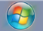
- Click the Start button from bottom left of the screen.
- On the bottom type “mail” into the search box and left click on “Mail” at the top.
- Left click on Show Profiles.
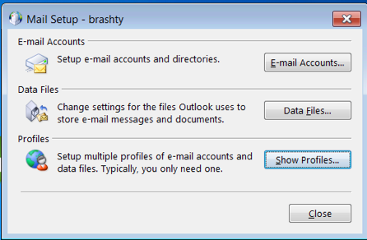
- If your old mailbox profile is currently listed (xxxx@gc.cuny.edu), select it and left click Remove. You should remove your old personal mailbox profile before adding your new non-human mailbox profile.
- Once you have removed your old mailbox profiles, left click Add.
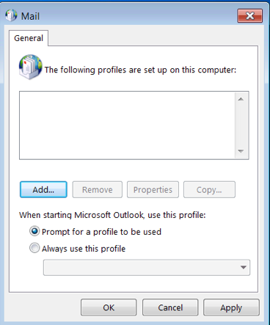

- Type in the name of the account you want to add.
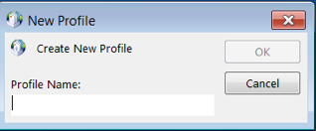
- Left click on OK.
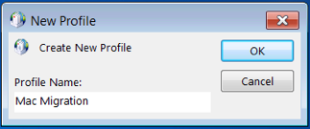
- Delete the email address box if it has anything in it. Your screen should look like this.
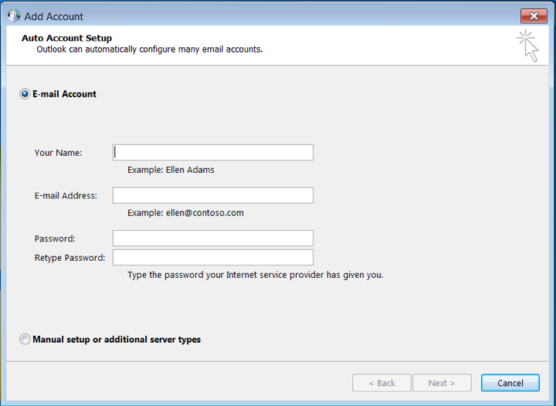
- Enter the name and the email address of the account you want. Leave the password empty and click Next.
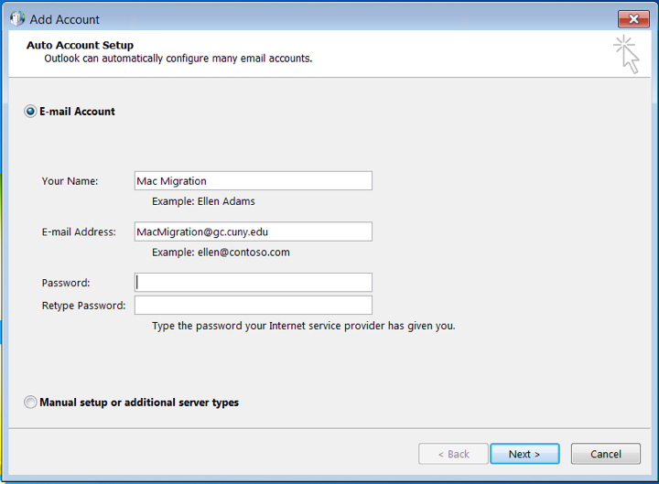
- If you get a popup like this select “Use another account”.
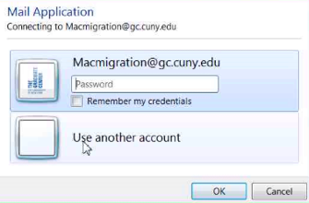

- Enter your legacy GC email address (Including @gc.cuny.edu) and your GC password. Also make sure to check “Remember my credentials”.
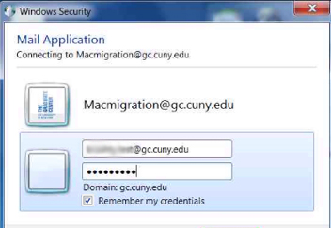
- Left click Finish.
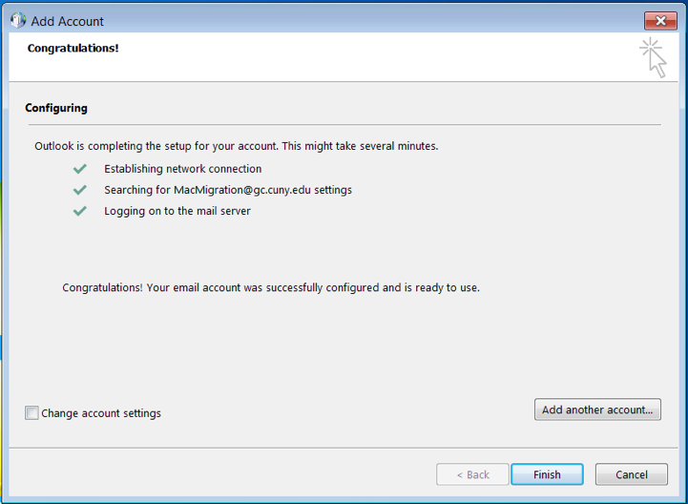

- Make sure “Prompt for a profile to be used” is selected and click OK.
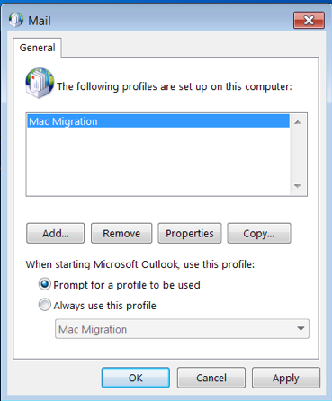
- Open Outlook.
- Choose your new profile at the prompt and click OK.
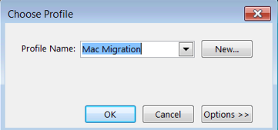
- Wait while inbox is synched.

