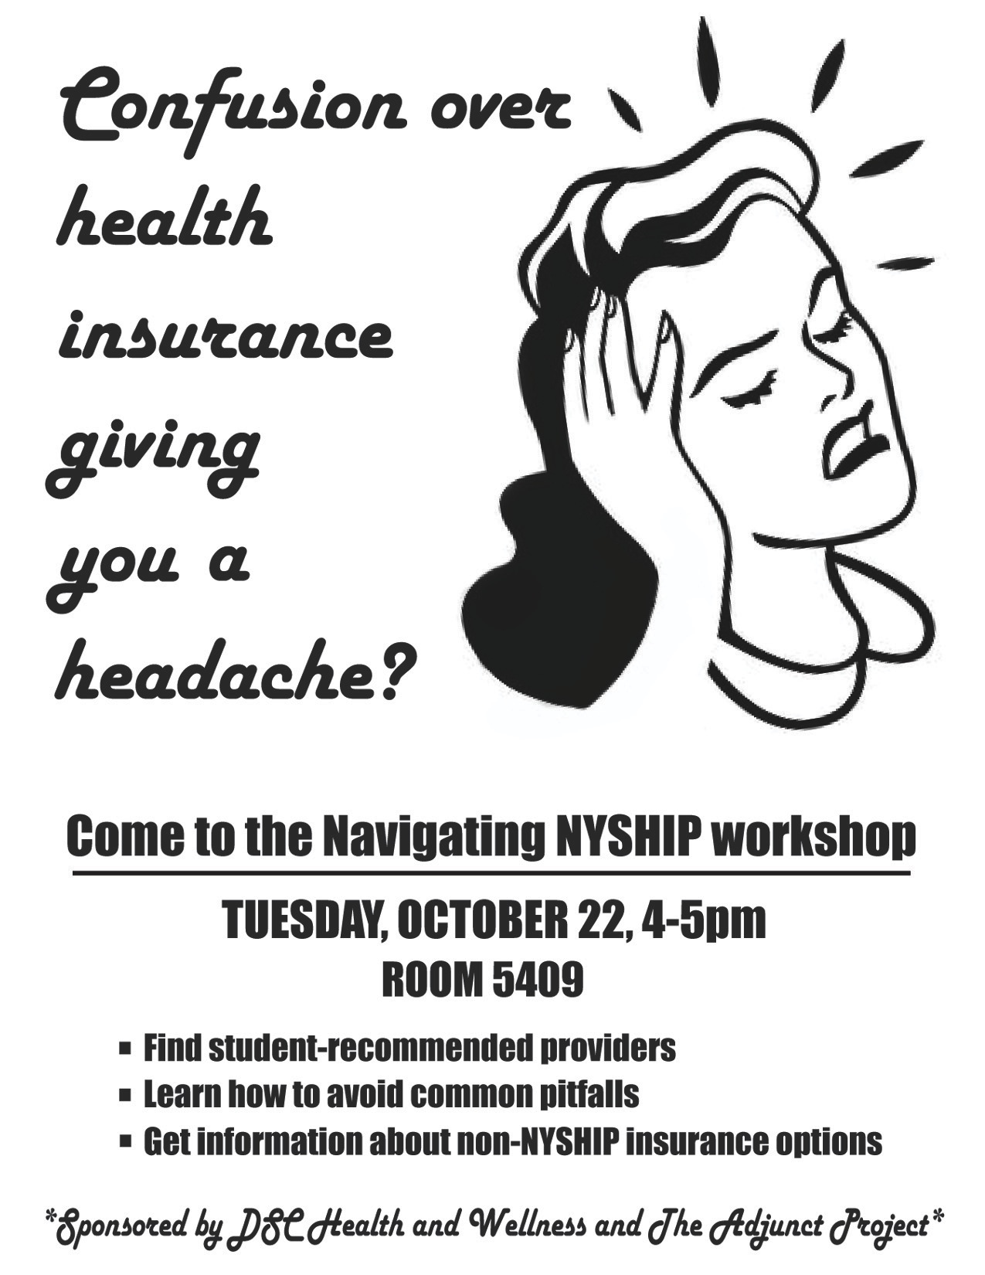

Come to the Navigating NYSHIP Workshop

THURSDAY, October 19th, at 3 PM

ROOM 5409

* + Find out details about NYSHIP
  + Learn how to avoid common pitfalls
  + Get information about non-NYSHIP insurance options

Led by Scott Voorhees (NYSHIP liaison)

Sponsored by DSC Health & Wellness